Scoring system

The Scoring System component is a combination of the scripts working together. One is attached to an empty object in the scene and the other one is nested into the object that would be collected. The first script is using the Unity UI engine.

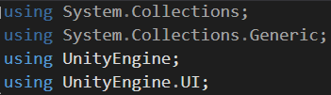

In the first lines of this class is declared an integer referring to the Score itself, and a reference to the UI where this score is going to be visualized inside a Text Box.

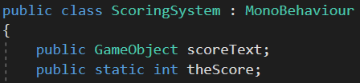

The script contains only one Update Method which simply find the Component holding the text box, fill the text “SCORE:” and the integer with number of Scores.

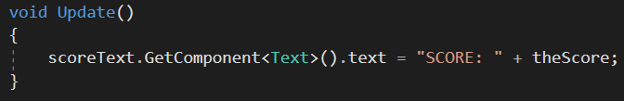

The second script is very short with just one Void OnTriggerEnter that detects the collision of the collectable object and update the Score by adding 10 points to that integer. It also destroys the object right after that collision.

